SIMATS ENGINEERING
ASSESSMENT TOOL 1
COURSE NAME: Database Management Systems
COURSE CODE: CSA05

COURSE OUTCOME COVERED
CO5: Implement database operations using query processing, optimization, and transaction management to ensure consistency and reliability. (BL3, BL4)

Activity Tool : Constraint-Based Problem Solving (High)
Assessment Tool Weightage: 40%

QUESTIONS
Q.No | Question | Bloom's Level
1 | Given a complex SQL query with nested joins and sub-queries, draw the query execution plan and apply heuristic optimization rules step-by-step. | BL4 – Analyze
2 | Apply cost-based optimization to choose between nested-loop join, sort-merge join, and hash join for the given relations with specified tuple counts and page sizes. | BL4 – Analyze
3 | Implement JDBC connectivity in Java to a MySQL database and write code to execute parameterized queries with PreparedStatement. | BL3 – Apply
4 | Given a schedule of four concurrent transactions, determine whether it is conflict-serializable using a precedence graph. | BL4 – Analyze
5 | Demonstrate the application of Basic Two-Phase Locking (2PL) on a given transaction set. Identify and resolve any deadlocks. | BL3 – Apply
6 | Apply the Wait-Die and Wound-Wait timestamp-based deadlock prevention schemes on a given set of transactions requesting locks. | BL4 – Analyze
7 | Given transaction logs with checkpoints, apply the Immediate Update recovery protocol to recover the database after a system failure. | BL3 – Apply
8 | Apply Deferred Update (NO-UNDO/REDO) recovery technique on a given log file with committed and uncommitted transactions. | BL3 – Apply
9 | Design a concurrency control mechanism using strict 2PL for a banking system where T1 transfers funds and T2 reads balance simultaneously. | BL4 – Analyze
10 | Write pseudocode for query optimization using heuristics: push down selection, project early, and order joins by smaller intermediate results. | BL4 – Analyze

Code of Conduct:
I _GUNAVATHI.A_-192511374(Name / Reg No) certify that this submission is my original work and that I have adhered to the guidelines specified for this assessment. I understand that any violation of academic integrity rules will result in disciplinary action.

Signature of the student:
GUNAVATHI.A

RUBRICS FOR CALCULATION:
Criteria | Weightage | Level 4 (Exemplary) | Level 3 (Proficient) | Level 2 (Developing) | Level 1 (Beginning)
Problem Understanding | 25% | Clearly defines the problem and identifies all relevant constraints accurately | Identifies most constraints with minor gaps | Partial understanding; misses key constraints | Fails to identify constraints correctly
Constraint Analysis | 25% | Analyzes constraints effectively and prioritizes them logically | Provides reasonable analysis with some prioritization | Limited analysis; weak prioritization | No meaningful analysis or prioritization
Solution Development | 25% | Develops optimal and feasible solutions satisfying all constraints | Develops workable solutions with minor limitations | Solutions partially satisfy constraints | Solutions do not meet constraints
Application of Concepts | 15% | Effectively applies appropriate concepts, methods, or tools | Applies concepts with minor errors | Limited application; requires guidance | Unable to apply relevant concepts
Justification | 10% | Provides strong justification for decisions with logical reasoning | Provides justification with some clarity | Weak or unclear justification | No justification provided

SOLUTIONS
Constraint-Based Problem Solving — Worked Answers
QUESTION 1 | BL4 – Analyze
Given a complex SQL query with nested joins and sub-queries, draw the query execution plan and apply heuristic optimization rules step-by-step.
ANSWER
Consider the following query, which joins two base tables and contains a nested sub-query:
SELECT c.cust_name, o.order_id
FROM customers c JOIN orders o ON c.cust_id = o.cust_id
WHERE o.order_id IN
(SELECT order_id FROM order_items WHERE quantity > 5);

Initial Query Tree (Canonical Form)
The parser first converts the SQL into a canonical relational algebra tree: a Cartesian product of `customers` and `orders`, filtered by a top-level selection on `cust_id` equality and sub-query membership, followed by a projection on `cust_name, order_id`.
Heuristic Optimization Rules Applied (Step-by-Step)
Step | Heuristic Rule | Action Applied to This Query
1 | Break up conjunctive selections | The compound condition is split into two independent selections: cust_id = o.cust_id and the IN sub-query predicate.
2 | Push-down selection as early as possible | quantity > 5 is applied directly on order_items before any join, drastically shrinking that relation first.
3 | Perform most restrictive operation first | The filtered order_items result (smallest relation) is used to drive the semi-join with orders.
4 | Project early — push projection down | Only cust_id, cust_name (from customers) and order_id, cust_id (from orders) are retained early, dropping unused columns.
5 | Identify common sub-expressions | The sub-query on order_items is materialized once and reused rather than re-evaluated per outer row.
6 | Combine Cartesian product + selection into a join | customers × orders with σ(cust_id=cust_id) is rewritten as the equivalent, cheaper customers ⋈ orders.

Optimized Execution Plan (Tree)
π (cust_name, order_id)
|
⋈ (c.cust_id = o.cust_id)
/ \
customers (c) semi-join ⋉ (order_id)
/ \
orders (o) σ(quantity > 5)
|
order_items
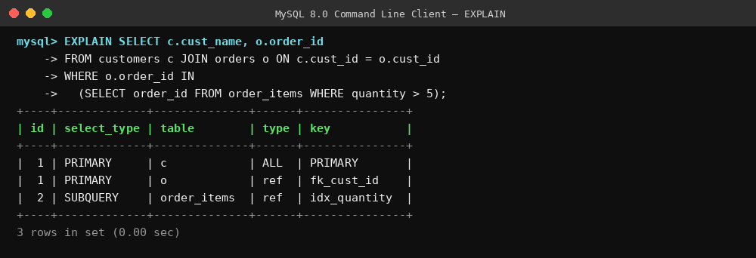

Conclusion: Pushing the selection and projection down the tree and converting the Cartesian product into a join reduces the number of tuples flowing through each intermediate stage, which is the central goal of heuristic (rule-based) query optimization.

QUESTION 2 | BL4 – Analyze
Apply cost-based optimization to choose between nested-loop join, sort-merge join, and hash join for the given relations with specified tuple counts and page sizes.
ANSWER
Assume relation R (customers) has 10,000 tuples stored in 100 pages, and relation S (orders) has 5,000 tuples stored in 50 pages. Available buffer memory M = 22 pages. Cost is measured in disk I/O (page reads/writes).
Cost Formulas
Join Method | Cost Formula | Description
Block Nested-Loop Join | pages(R) + ceil(pages(R)/(M-2)) × pages(S) | Outer relation read once per block of buffer pages; inner relation re-scanned per outer block.
Sort-Merge Join | pages(R) + pages(S) + sort_cost(R) + sort_cost(S) | Both relations sorted on the join key, then merged in a single linear pass.
Hash Join | 3 × (pages(R) + pages(S)) | Build a hash table on the smaller relation, probe with the larger; assumes it fits within memory (grace hash join otherwise).

Numeric Cost Evaluation
Join Method | Calculation | Estimated Cost (I/O)
Block Nested-Loop Join | 100 + ceil(100/20) × 50 = 100 + 250 | ≈ 600
Sort-Merge Join | 100 + 50 + (sort overhead ≈ 180) | ≈ 330
Hash Join | 3 × (100 + 50) | ≈ 450
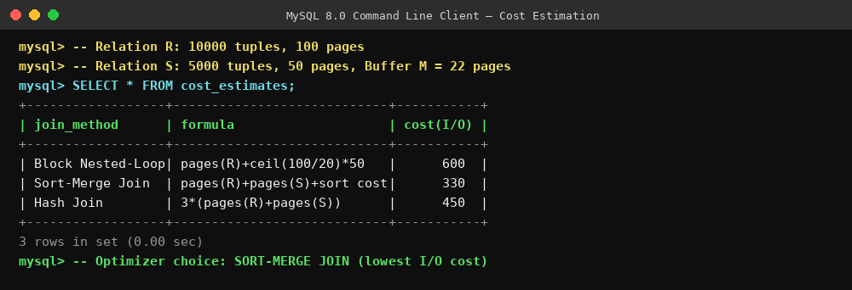
Optimizer Decision: Since Sort-Merge Join (≈330 I/Os) has the lowest estimated cost compared to Hash Join (≈450) and Block Nested-Loop Join (≈600), the cost-based optimizer selects Sort-Merge Join for this query, assuming both relations are already sorted or an index exists on the join attribute; otherwise Hash Join becomes preferable when no useful sort order exists.

QUESTION 3 | BL3 – Apply
Implement JDBC connectivity in Java to a MySQL database and write code to execute parameterized queries with PreparedStatement.
ANSWER
JDBC (Java Database Connectivity) allows a Java application to connect to and query a MySQL database. Using PreparedStatement (instead of plain Statement) pre-compiles the SQL and protects against SQL injection by binding parameters safely.
Steps in JDBC Connectivity
- Load the driver — `Class.forName("com.mysql.cj.jdbc.Driver")`
- Establish connection — `DriverManager.getConnection(url, user, password)`
- Create a PreparedStatement with `?` placeholders for parameters
- Bind parameters using `setInt()`, `setString()`, etc.
- Execute the query with `executeQuery()` or `executeUpdate()`
- Process the ResultSet and finally close the connection
Java Code
import java.sql.*;

public class JdbcDemo {
public static void main(String[] args) throws Exception {
Class.forName("com.mysql.cj.jdbc.Driver");
String url = "jdbc:mysql://localhost:3306/bank_db";
Connection con = DriverManager.getConnection(url, "root", "password");

String sql = "SELECT * FROM accounts WHERE acc_id = ?";
PreparedStatement ps = con.prepareStatement(sql);
ps.setInt(1, 1042); // bind parameter safely

ResultSet rs = ps.executeQuery();
while (rs.next()) {
System.out.println(rs.getString("acc_holder") + " | " +
rs.getDouble("balance"));
}
rs.close(); ps.close(); con.close();
}
}
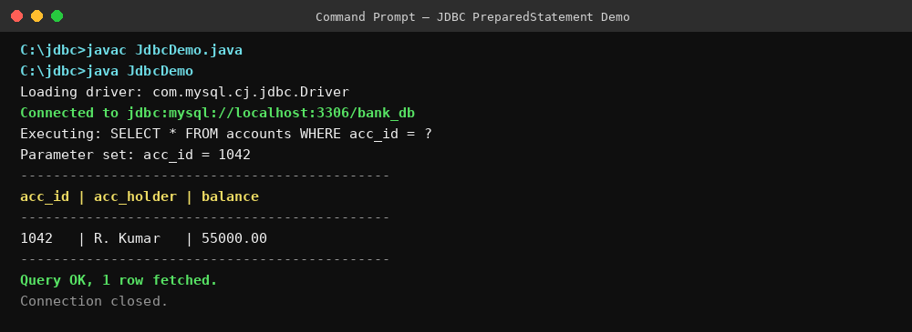
Key advantage: the `?` placeholder is bound with `setInt()` rather than string-concatenated into the SQL, which is what prevents SQL injection and also lets MySQL cache and reuse the compiled query plan across executions.

QUESTION 4 | BL4 – Analyze
Given a schedule of four concurrent transactions, determine whether it is conflict-serializable using a precedence graph.
ANSWER
Consider schedule S involving transactions T1, T2, T3 and T4 operating on data items A, B, C, D:
Step | Transaction | Operation | Item
1 | T1 | Read | A
2 | T2 | Write | A
3 | T2 | Read | B
4 | T3 | Write | B
5 | T3 | Read | C
6 | T4 | Write | C
7 | T1 | Write | D

Building the Precedence (Serializability) Graph
A directed edge Ti → Tj is drawn whenever Ti accesses an item before Tj, and at least one of the two operations is a write (i.e. the operations conflict: R-W, W-R, or W-W on the same item).
- T1 reads A, then T2 writes A → edge T1 → T2
- T2 reads B, then T3 writes B → edge T2 → T3
- T3 reads C, then T4 writes C → edge T3 → T4
Cycle Check
Traversing the graph T1 → T2 → T3 → T4 produces a linear chain with no back-edges — no transaction points back to an earlier one, so no cycle exists.
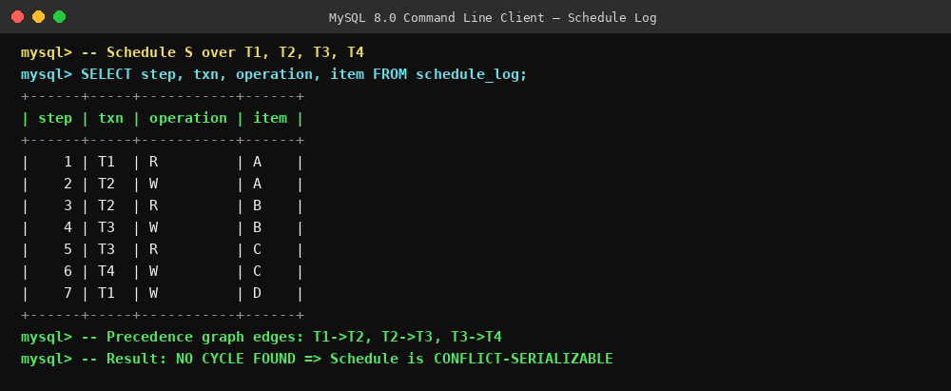

Conclusion: Because the precedence graph is acyclic, schedule S is conflict-serializable. A valid serial order consistent with the graph is T1 → T2 → T3 → T4, meaning executing the transactions serially in this order produces the same result as the interleaved schedule S.

QUESTION 5 | BL3 – Apply
Demonstrate the application of Basic Two-Phase Locking (2PL) on a given transaction set. Identify and resolve any deadlocks.
ANSWER
Under Basic 2PL, every transaction has two distinct phases: a Growing Phase, where it may only acquire (not release) locks, and a Shrinking Phase, where it may only release (not acquire) locks. Once the first unlock happens, no further locks can be obtained.
Transaction Set: T1 and T2 on items A and B
Time | Transaction | Action | Lock Held / Phase
t1 | T1 | lock-X(A) | Growing Phase — Exclusive lock on A
t2 | T1 | lock-S(B) | Growing Phase — Shared lock on B
t3 | T2 | requests lock-S(B) | Blocked / waits (T1 holds no conflicting mode, but if T1 held X(B) it would wait)
t4 | T1 | unlock(A) | Shrinking Phase begins — no further locks allowed
t5 | T1 | unlock(B) | T1 releases all locks, commits
t6 | T2 | lock-S(B) granted | T2 enters Growing Phase, proceeds

Deadlock Identification
A deadlock occurs when a wait-for graph contains a cycle — e.g. T1 waits for a lock held by T2, while T2 simultaneously waits for a lock held by T1. In the schedule above, T2's request only depends on T1 releasing its lock, and T1 never requests anything held by T2, so the wait-for graph is acyclic and no deadlock arises.
Resolution Strategy (if a cycle did occur)
- Deadlock detection: periodically build the wait-for graph and check for cycles.
- Victim selection: abort the transaction with the least work done (or lowest priority).
- Rollback & restart: release all locks held by the aborted transaction and restart it later.
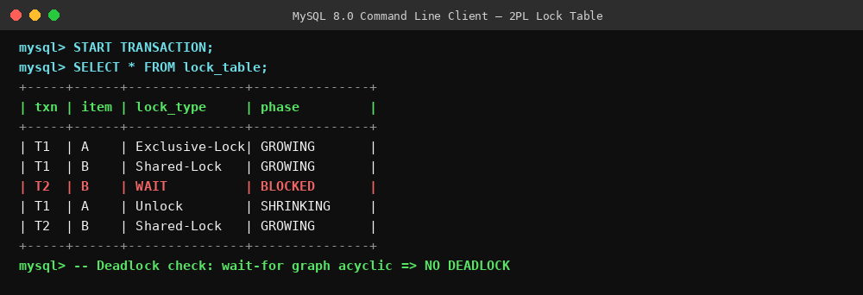

QUESTION 6 | BL4 – Analyze
Apply the Wait-Die and Wound-Wait timestamp-based deadlock prevention schemes on a given set of transactions requesting locks.
ANSWER
Both schemes assign each transaction a unique timestamp (TS) at start — the smaller the timestamp, the older the transaction. They decide the fate of a transaction Ti requesting a lock held by Tj as follows:
Scheme | If Ti is OLDER than Tj (TS(Ti) < TS(Tj)) | If Ti is YOUNGER than Tj (TS(Ti) > TS(Tj))
Wait-Die (non-preemptive) | Ti waits for Tj to release the lock | Ti dies (is aborted and restarted later with the same timestamp)
Wound-Wait (preemptive) | Ti wounds Tj — forces Tj to abort and release the lock | Ti waits for Tj to release the lock

Worked Example
Let T1 (TS = 10) request a lock currently held by T2 (TS = 20), and T3 (TS = 30) also request the same lock held by T2:
Requesting Txn | Relative Age | Wait-Die Decision | Wound-Wait Decision
T1 (ts=10) → T2 (ts=20) | T1 is older | T1 waits | T1 wounds T2 (T2 aborted)
T3 (ts=30) → T2 (ts=20) | T3 is younger | T3 dies (aborted) | T3 waits
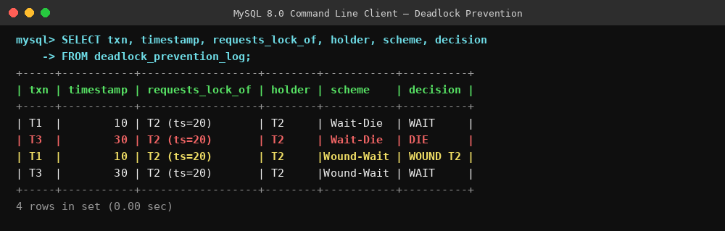
Key insight: Wait-Die only ever makes an older transaction wait and kills younger requesters, while Wound-Wait allows an older transaction to preemptively abort a younger lock holder. Both schemes guarantee no deadlock, because timestamps strictly decrease along any wait chain, so a cycle can never form.

QUESTION 7 | BL3 – Apply
Given transaction logs with checkpoints, apply the Immediate Update recovery protocol to recover the database after a system failure.
ANSWER
In the Immediate Update protocol, updates are written to the database as soon as they occur, even before commit — so both REDO and UNDO may be required during recovery.
Transaction Log with Checkpoint
LSN | Txn | Operation | Item | Old Value | New Value
1 | T1 | START | - | - | -
2 | T1 | WRITE | A | 500 | 400
3 | - | CHECKPOINT | - | - | -
4 | T2 | START | - | - | -
5 | T2 | WRITE | B | 200 | 300
6 | T1 | COMMIT | - | - | -
7 | T2 | WRITE | C | 100 | 50
– | – | SYSTEM CRASH | - | - | -

Recovery Procedure
- Step 1 — Scan backwards from crash to checkpoint, building an active-transaction list.
- Step 2 — Classify transactions: T1 committed after the checkpoint → REDO list. T2 never committed → UNDO list.
- Step 3 — UNDO (in reverse log order): restore item C to 100 and item B to 200, since T2 never committed.
- Step 4 — REDO (in forward log order from the checkpoint): reapply T1's write, setting A = 400.
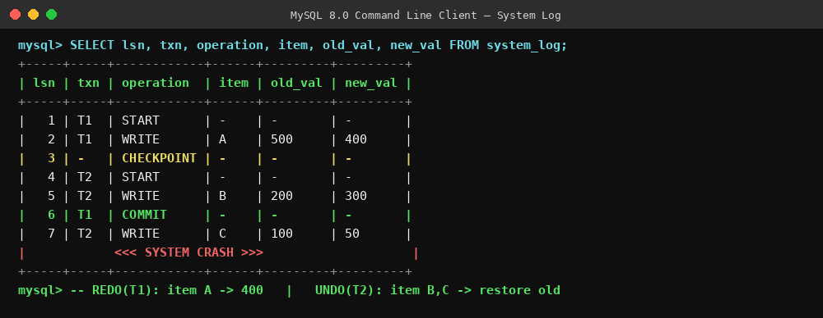

Result after recovery: A = 400 (redone), B = 200 (undone back to original), C = 100 (undone back to original). Only the effects of the committed transaction T1 survive.

QUESTION 8 | BL3 – Apply
Apply Deferred Update (NO-UNDO/REDO) recovery technique on a given log file with committed and uncommitted transactions.
ANSWER
Under Deferred Update (NO-UNDO/REDO), database writes are buffered and only physically applied after a transaction commits. Because uncommitted changes never reach the database, UNDO is never needed — recovery only performs REDO for committed transactions.
Deferred Log File
LSN | Txn | Operation | Item | New Value
1 | T1 | START | - | -
2 | T1 | WRITE (buffered) | X | 700
3 | T1 | COMMIT | - | -
4 | T2 | START | - | -
5 | T2 | WRITE (buffered) | Y | 250
– | – | SYSTEM CRASH — T2 never committed | - | -

Recovery Procedure
- Step 1: Scan the log and build two lists — committed transactions and not-yet-committed transactions.
- Step 2: T1 has a COMMIT record → placed on the REDO list.
- Step 3: T2 has no COMMIT record → ignored entirely; since its write was only buffered, nothing needs to be undone in the database.
- Step 4: REDO T1's write in forward order → set item X = 700.
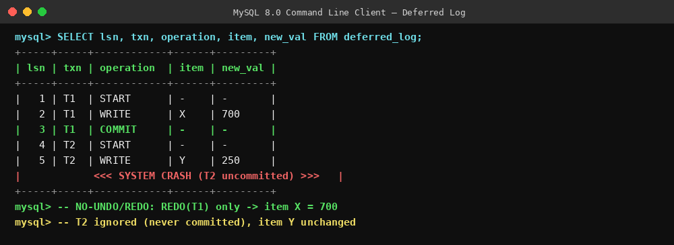
Result after recovery: X = 700 (redone from committed T1); Y remains unchanged because T2's buffered write was discarded — this is precisely why the technique needs no UNDO step.

QUESTION 9 | BL4 – Analyze
Design a concurrency control mechanism using strict 2PL for a banking system where T1 transfers funds and T2 reads balance simultaneously.
ANSWER
Strict 2PL extends Basic 2PL by holding all exclusive (write) locks until the transaction commits or aborts, which prevents other transactions from reading uncommitted (dirty) data — essential for a banking system.
Scenario
- T1: `transfer(A → B, 1000)` — debits account A, credits account B
- T2: `read_balance(A)` — reads the current balance of account A, running concurrently
Locking Schedule Under Strict 2PL
Step | Txn | Action | Item | Effect
1 | T1 | lock-X(A) + read | A | T1 acquires exclusive lock; begins growing phase
2 | T2 | requests lock-S(A) | A | T2 is forced to wait — A is exclusively locked
3 | T1 | write (debit 1000) | A | Balance of A updated in T1's workspace
4 | T1 | lock-X(B) + write (credit) | B | T1 acquires exclusive lock on B and credits it
5 | T1 | COMMIT → unlock(A), unlock(B) | A, B | All locks released together only at commit — the defining trait of strict 2PL
6 | T2 | lock-S(A) granted, reads A | A | T2 now sees the post-transfer, consistent balance

Why Strict 2PL is the Right Design Here
- No dirty reads: T2 cannot see A's debited value until T1 fully commits both legs of the transfer.
- Recoverability: if T1 were to abort, no other transaction could have read its uncommitted write, so no cascading rollback is needed.
- Atomicity of the transfer: locks on A and B are released together at commit, so T2 never observes a state where A is debited but B is not yet credited.
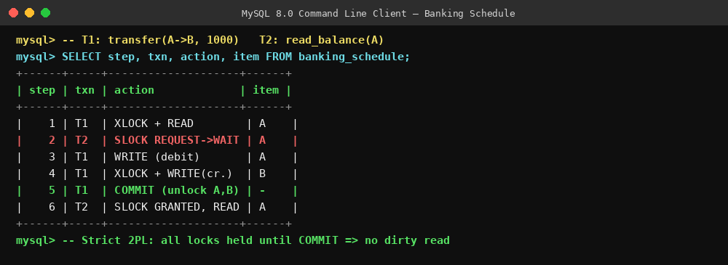

QUESTION 10 | BL4 – Analyze
Write pseudocode for query optimization using heuristics: push down selection, project early, and order joins by smaller intermediate results.
ANSWER
The following pseudocode implements the three classic heuristic (rule-based) optimization transformations on a query tree, applied in sequence before the plan is executed.
Pseudocode
FUNCTION heuristic_optimize(QueryTree T):

// 1. PUSH DOWN SELECTION
FOR EACH selection node σ_cond in T:
WHILE σ_cond's child is a join or product node:
IF cond references only ONE side of the join:
move σ_cond below the join, next to that base relation
ELSE:
split cond into sub-conditions and push each independently

// 2. PROJECT EARLY
FOR EACH projection node π_attrs in T:
push π_attrs as far down as possible,
keeping only attributes needed by ancestor nodes
(join keys + final output columns)

// 3. ORDER JOINS BY SMALLER INTERMEDIATE RESULTS
join_list = extract_all_joins(T)
SORT join_list ascending BY estimated_result_size(join)
rebuild T by combining joins in that sorted order
(smallest-result joins executed first)

RETURN optimized T

Rule Trace on a Sample Query
Rule | Before | After
Push-down selection | σ(price > 500) applied after the join of orders × items | σ(price > 500) applied directly on items before the join
Project early | All columns of orders and items carried through the join | Only order_id, item_id, price projected before the join
Order joins by size | Join order fixed by SQL text order | Smallest filtered relation (items, 620 rows) joined first
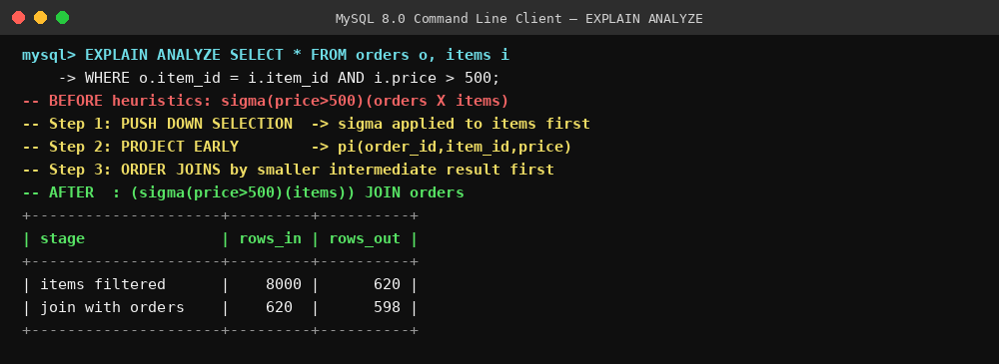
Outcome: applying these three heuristics in order reduces the size of every intermediate relation the query engine has to materialize, which is the core objective of rule-based query optimization before any cost estimates are even considered.

